BPttA (2013-15) built on the success of the pilot Re-Imaging Communities Programme which completed in 2009 and was financially supported by the PEACE III Programme managed by the Special EU Programmes Body (SEUPB), the Arts Council of Northern Ireland and the International Fund for Ireland (IFI).

It responded to the need to address the physical and psychological legacy of segregation and division - increasing pride and strengthening relationships within communities through artistic expression and, where relevant, assisting with the process of replacing divisive symbols and emblems with collaborative and positive artwork.

This grants-based programme was open to non-governmental organisations and Local Authorities in Northern Ireland and the Southern Border Counties and a separate two stage application process was adopted. Stage One supported arts based community consultation to identify local issues, themes and sites for public art and Stage Two involved the production of the agreed public art work.

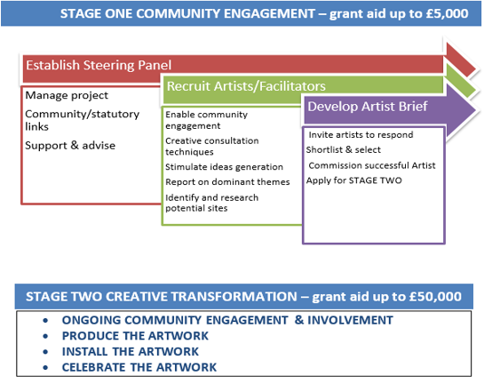
During Stage One and Two professional artists collaborated with local communities to help residents outwardly express their combined vision via completed public artwork. Day to day management and support was provided to local Steering Panels by the BPttA Manager, two Community Development Officer and Administrator. A BPttA Consortium was established to provide oversight and strategic advice.

Impact Appraisal
Interest in the Programme has been high, with:
- Just over £2 million invested in communities across NI and the southern border counties;
- 54 community led consultation projects and 32 public artworks have been funded;
- Geographies span interfaces, contested spaces and areas which are economically disadvantaged and marginalized;
- In excess of 12,000 people have taken part in BPttA activities;
- Almost 1,000 artist led workshops have been delivered. Some of which have been held on a cross-border basis;
- Over 10,000 individuals contributed to community consultations and participated in arts based activity. Input from young people and those from BME and/or minority religious backgrounds has been actively sought;
- Around 120 professional artists have facilitated community engagement and the delivery of the final artworks;
- Innovative public art symbolizing a desire for peace and reconciliation has been launched in 32 locations.

Essentially, the process helped to develop stronger, more active communities that are welcoming and inclusive. Places that everyone can enter and enjoy irrespective of their race, nationality or religious background. The following impacts were identified against the five BPttA Strategic Themes:

- Regeneration through the Arts: Use of the arts to create a united, positive identity
- Acknowledges that an absence of cultural “branding” does not mean that a space is perceived to be non-threatening or safe;
- Participants had little or no experience of community arts projects prior to the BPttA;
- Included areas of economic disadvantage and decline;
- Challenged communities to reconsider traditional representation of culture and public art;
- High quality artistic commissions from acclaimed artists & Artist – Community collaboration;
- Links to wider regeneration initiatives;
- Additional financial leverage resulted from BPttA investment.
- Positive Relations: Use of the arts to challenge prejudice and progress community relations
- Projects in areas with high levels of sectarian & racial crimes, incidents and tensions;
- Projects with significant re-imaging elements involving peace walls, re-imaging of paramilitary murals, offensive graffiti or flags;
- Community arts practice helped develop a combined community vision;
- Acknowledgement of sectarian/racist attitudes within communities;
- Commonalities of experience and aspirations explored;
- Commitment to make neighbourhoods feel more welcoming;
- Positive redefinition of physical space and identity;
- Peace & Reconciliation: Using community led participative arts to deliver reconciliation
- Greater self-reported respect for people’s differences;
- Acceptance of diversity and need for inclusion of minorities;
- Support for further community arts & peacebuilding projects;
- Greater capacity and higher profile for community groups;
- Lasting partnerships established & community support for the BPttA projects;
- Statutory support for arts based peacebuilding.
- Community Cohesion: Empowerment, belonging and nurturing social inclusion, active participation and personal development
- Participants felt a greater sense of belonging to their community;
- Involvement of marginalised groups;
- Provided a common purpose & helped residents influence decision-making;
- Benefited from significant volunteer efforts;
- Established “sense of place”;
- Participants more willing to work with others on something to improve the neighbourhood
- Connecting Communities: Connecting communities throughout NI & Border areas
- Generated cross-border projects, cross-community and inter-racial discussions, inter-generational contact;
- Focused on making connections within communities and developing local partnerships;
- Some projects involved in sharing good practice on a cross-border basis
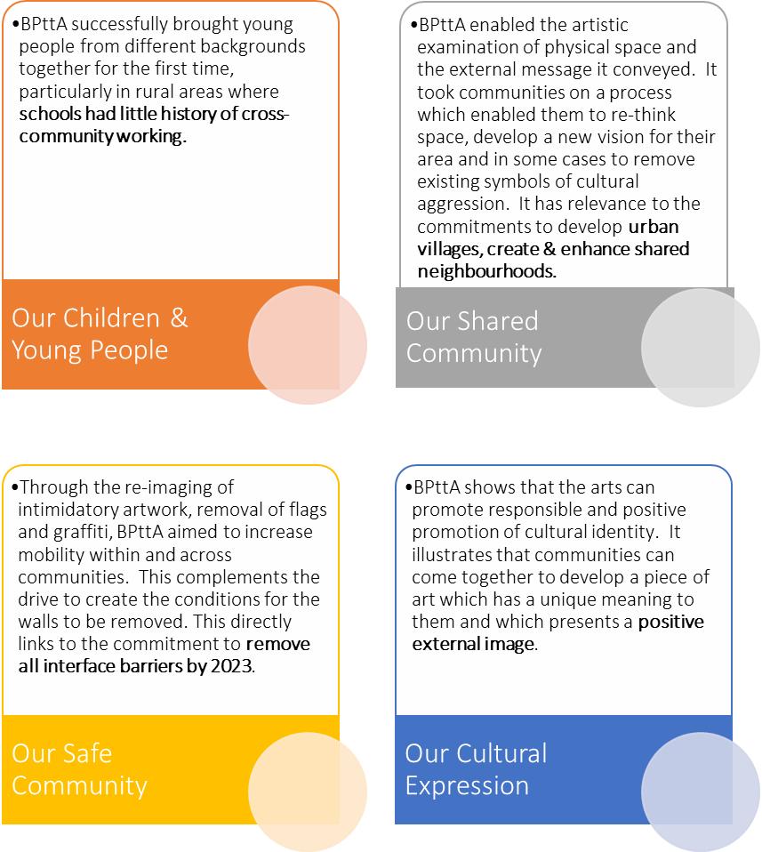

New Programme Focus
The appetite for a “re-imaging” programme remains both at a community and strategic level. Therefore, it is important that the Arts Council begins to examine the potential to develop the work conducted under the BPttA, particularly with regards to the potential for inter-agency collaboration in order to maximise impact against T:BUC priorities (left).
The arts function of DCAL, DSD, elements of OFMdFM and the Employment Service element of DEL will form a new Department for Communities and work is ongoing on an Arts and Culture Strategy 2016-26. This explores the potential of the arts and culture sector to help achieve broader social and economic goals such as social inclusion and cohesion, urban regeneration, tourism, inward investment, employment, development of high added value creative industries, education and health. This opens up substantial opportunities for a new Programme approach which combines arts/good relations facilitated physical and social regeneration.

Any future Programme must be firmly integrated into area based social and physical regeneration initiatives linking community support, arts, good relations and economic objectives. Rather than an open application call, we recommend that a collaborative and targeted approach is undertaken to help identify those areas most in need of support using the following delivery structures:
- Consortium of relevant strategic stakeholders (e.g. Arts Council, DOJ, CRC, OFMdFM, Housing Executive, Local Government) providing guidance and accountability;
- Delivery Partners will have expertise in both arts and peace-building - reinforcing the inter-dependence of both disciplines to achieving Programme outcomes. There will be centralised coordination and administration and delivery partners will provide technical assistance to community beneficiaries in their area of expertise;
- Planning Networks will have multi-agency representation - initially making recommendations for areas for inclusion onto the Programme;
- Steering Panels will be representative of groups and residents within the community. They will also benefit from statutory representation providing advice, signposting and support to achieve their objectives.
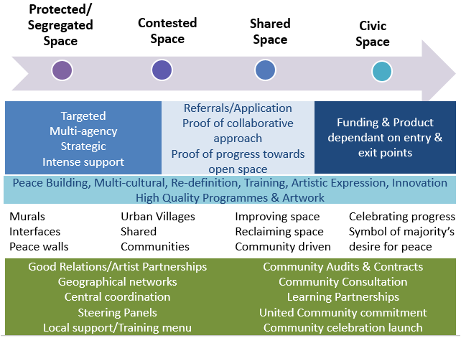
There are a number of linkages to be explored:
- PEACE IV (2014-20): The new Peace Programme aligns with the objectives of T:BUC and proposes activity in a number of areas including Shared Spaces and Services and Building Positive Relations at a Local Level;
- T:BUC: Budget 2015-16 set aside £10m for T:BUC . The Fresh Start Implementation Plan commits a further £500m (in addition to the Stormont House Agreement £2b support package). This includes £60m to build community relations through initiatives such as removing "peace walls.” Plans for a Commission to examine issues of flags, identity, culture and tradition will proceed, and the Assembly will regulate parades. Departments will submit bids;
- IFI: Allocation of up to £45m over the next five years to expand and intensify the current Peace Walls and Peace Impact programmes and introduce two new initiatives linked to education and youth training.

Representatives from the Arts Council, IFI, SEUPB, the Office of the First Minister and deputy First Minister, Northern Ireland Housing Executive, Department of Social Development, Rural Community Network, NI Community Relations Council, the Association of Local Authority Arts Officers and the Institute for Conflict Research (ICR).

