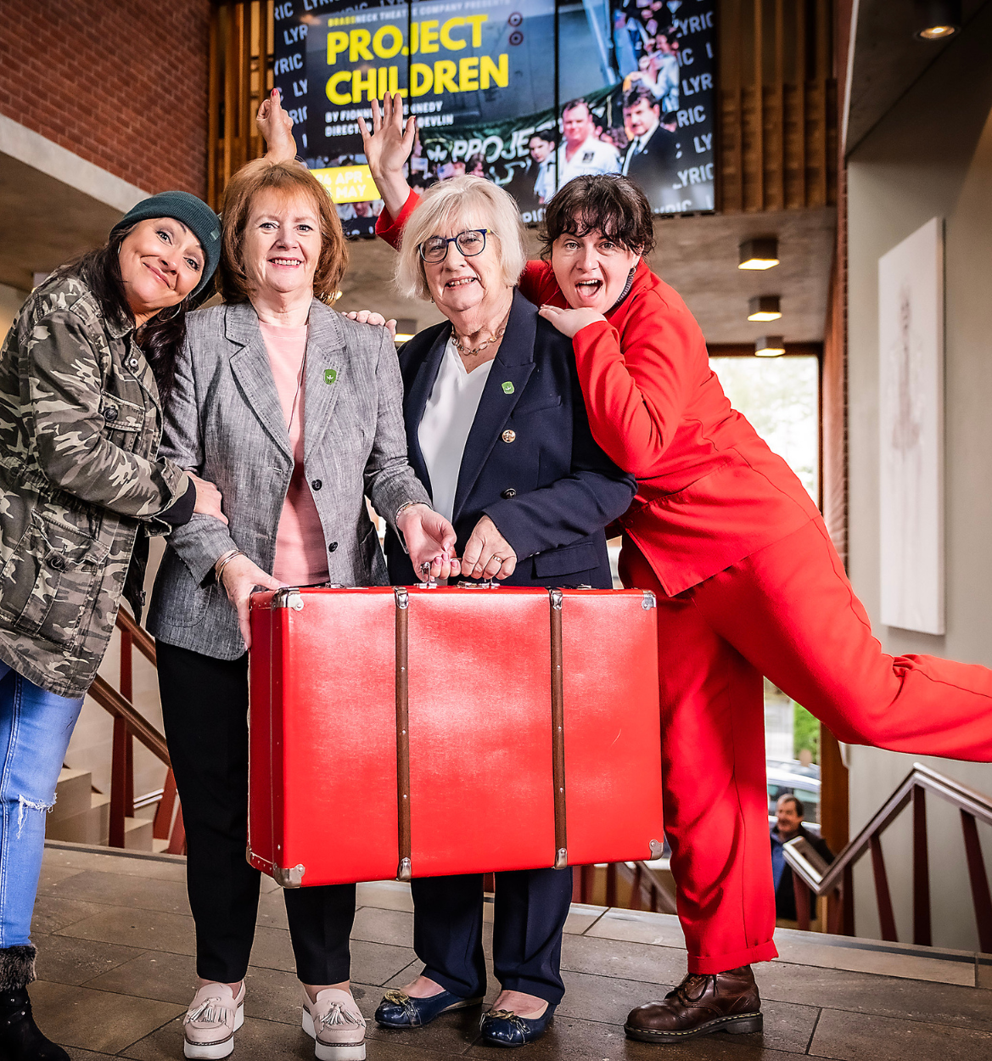

`

Annual Business Plan
2025-2026
artscouncil-ni.org
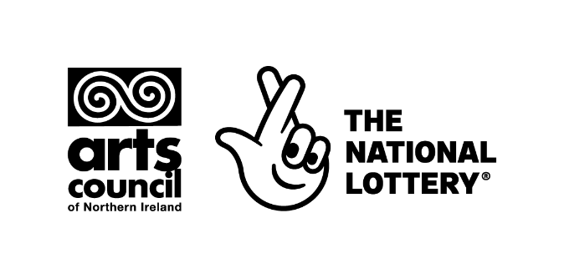
Arts Council of Northern Ireland
Business plan
2025-2026

Foreword from Chief Executive

On behalf of the Arts Council of Northern Ireland, I am pleased to present our Business Plan for 2025–2026. This plan translates our ten-year strategy into concrete actions for the year ahead and responds directly to the priorities set out in the Minister’s Letter of Expectations. The letter recognises the continuing budgetary pressures across the public sector and challenges us to ensure that the resources available are directed where they can make the greatest impact.

In response, this plan focuses on widening access to the arts, with a particular emphasis on younger people from deprived areas, those living in rural communities, and people not currently engaged in arts activities. We will also expand our work with district councils, ensuring regular consultation and coordination. This work will include a new artist in residence scheme for local authorities. In line with the Minister’s expectations, we are structuring funding opportunities to encourage innovation and collaboration across the sector, while streamlining our processes to increase accessibility.

Other commitments for the year ahead include: launching a new small arts programme to increase participation from underrepresented groups; strengthening partnerships with the health and education sectors; and enhancing the wellbeing support available for individual artists. We will also progress our international partnerships, broaden opportunities for innovation, and continue to evidence the social and economic value of the arts.

The Arts Council remains dedicated to ensuring that our work delivers maximum community benefit. This plan demonstrates how we will foster deeper collaboration across sectors, and ensure that public investment in the arts reaches those who will benefit most. I want to thank artists and arts organisations for their resilience and creativity, and our sponsor department and the National Lottery for their continued support. Together, we will continue to strengthen the arts in Northern Ireland, making them accessible to more people, and ensuring they play a central role in the wellbeing, identity and prosperity of our society.

Roisin McDonough
CEO
Arts Council of Northern Ireland

- Who we are

Vision
A society where all people can experience a thriving arts sector that is recognised as essential to creativity, wellbeing and social and economic prosperity.

Mission

We develop and champion the arts in Northern Ireland through investment and advocacy.

- Our values

Expertise
We use our experience and expertise to support the arts sector in NI through investing, advocating and evidencing the impact of the sector.

Inclusion
We recognise the importance of diversity in the arts sector and are committed to being inclusive and accessible to all.

Collaboration
We value our strong relationships with partners and their ability to enhance arts programmes across NI and beyond.

Integrity
We are open, transparent, and fair in how we distribute public funding.

- What we do

Support and develop high-quality arts activity – we invest public funding to create opportunities for more people, from all backgrounds and communities, to enjoy and take part in the arts.

Distribute National Lottery funds – through applications to our National Lottery funding programmes, we’re able to fund projects that develop new arts activity, supporting individuals, communities and organisations.

Develop and improve the knowledge, appreciation and practice of the arts – we produce strategic research and intelligence and work with partners in the cultural sector to advise the Department for Communities, Local Authorities and other bodies on matters relating to the arts. We also have strong international links in the UK and beyond.

Increase public access to and participation in the arts – we want to create an innovative, creative and diverse society where people can fulfil their potential and contribute fully to society.

Raise the profile of the arts in Northern Ireland – we’re the national voice for the arts in Northern Ireland, promoting the quality, value and importance of the region’s artists/arts organisations and the impact that they make.

Influence decision-makers - the arts take place in many different settings. They can have a dramatic impact on the quality of people’s lives and the places in which they live and work. The arts are also frequently at the heart of initiatives for economic and social regeneration. Our job is to ensure that the contribution that the arts can make is recognised.

Develop international opportunities in the arts – we have developed partnerships with cultural organisations such as the British Council and we work collaboratively with all the UK nations to promote Northern Ireland art internationally. We encourage international exchange and collaboration between artists and arts organisations.

Work collaboratively with stakeholders and the public – seeking and listening to feedback through our formal consultations and open conversations, we ensure that our programmes of work deliver public benefit.

Work across art forms – including community arts and education, circus and carnival, creative industries, drama, dance, festivals and venues, literature, music, opera, theatre, traditional arts, visual arts, craft and many more.

Foster innovation between the arts and the wider creative industries – by facilitating skills development and knowledge transfer in digital technology for the arts sector, encouraging collaboration, leveraging additional funding and expertise through key partners, and encouraging the creation of digital artwork to ensure the arts evolve with audiences.

- Draft ten-year strategic plan:

Our draft strategy follows an outcome-based approach. This means that we have focused first on what we would like to see achieved for the arts sector and then used this to inform what we do. We have derived a set of outcomes for the art sector, and a set of outcomes that the sector then delivers as a result for society. The outcomes overlap and are reliant on one another. They are used to frame our business plan.

Outcomes for the arts sector
Outcome 1: A more financially stable arts sector. |  | Outcome 2: A sector that develops, looks after its people, and is more inclusive. |  | Outcome 3: A sector that is better supported to develop through experimentation and innovation.
Outcomes for society
Outcome 4: A sector that contributes to social and economic benefits and cares about the environment | Outcome 5: More people from all backgrounds can enjoy arts experiences. |  | Outcome 6: A sector that is more valued across society and government.

- Business Plan 2025-2026: Context

The Arts Council works directly with a range of vital strategic partners; ensuring that grant programmes and strategic initiatives reach those most in need of intervention. To best contribute to Programme for Government, Department for Communities (DfC) Business Plan and Ministerial priorities, particularly those set out in Minister Lyon’s Letter of Expectations dated 5 February 2025 which includes expectations of close collaboration with local authorities, the development of cross cutting partnerships is essential. This is also aligned to the Minister’s letter sent to the District Council’s Chief Executives on 6th May 2025, encouraging us to work together to better establish how the arts could be better foregrounded to deliver community benefit.

This plan is also aligned to the funding objectives of the National Lottery which aims to bring quality cultural experiences to people in communities, support artists and cultural organisations, foster creativity and respond to societal needs. Creativity and the arts have been shown to impact positively on urban and rural communities, wellbeing, place-making, economy, tourism and improve educational outcomes. Underpinned by the arts and cultural sector, the creative industries too are a vital driver of the NI economy.

We will continue to build our existing partnership with our Sponsor Department (DfC) to enable strategic alignment between the aims, objectives and expected outcomes and results of the Arts Council and the Department. This business plan has been developed prior to the introduction of the Department’s Arts Policy and we would therefore review this plan to ensure alignment and joint strategic objectives.

Particular focus has been placed on key areas identified in the letter of expectations, including:

- Promoting and supporting the contribution the arts can make in terms of equality of access and opportunity across socioeconomic grouping, age, geography;

- Encouraging greater participation, particularly from people and communities that might feel that artistic activities don’t quite fit with their lives; and

- Encouraging deeper collaborations and partnerships; supporting greater financial sustainability across the arts; and identifying approaches and opportunities that maximise the value of the arts sector in particular in health & general wellbeing, education and the economy

Financing the Arts

The indicative resource allocation for 2025/26 is £10,616,000 and £1,485,000 for capital projects, combined this equates to £12,101,000. A breakdown of these budgets is provided below.

Capital funding continues to present significant challenges and the indicative opening capital budget for 2025/26 at £1,485,000 effectively limits investment to meeting the historical, existing demand from arts organisations applying to our capital grants programme each year.

The Arts Council also receives an annual budget from the National Lottery. The projected, estimate budget for 2025/26 currently stands at £9,774,171.

  - Progress in 2024/25

Through focussed effort we made progress on a wide range of activity in the last year. Particular highlights included:

- We provided funding to artists and arts organisations through schemes such as our Annual Funding Programme, National Lottery Project Funding, Rural Engagement Arts Programme, Arts and Older People and Support for Individual Artists Programme.
- We have developed the Mental Health and Arts Programme and have piloted self-care workshops for artists.
- We have completed impact work to estimate the economic and social value of ACNI’s investment portfolio. This included 4 case studies to evidence social value of the arts. These included Verbal Arts, The Lyric, Ulster Orchestra and Theatre & Dance NI
- We have been developing a draft Partnership and Engagement Plan for 2025-2028
- We have conducted surveys to assess levels of Client Satisfaction and to explore the Social Class composition of our grantees.
- We have expanded our Investment Survey, sent now to 160 AFP and National Lottery Project Funding (NLPF) clients.
- We have delivered a knowledge exchange and networking event on arts, mental health and on the living and working conditions of artists
- We delivered a Digital Art Showcasing event, the one-day free exhibition was an opportunity for the public and wider arts sector to experience experimental and innovative digital arts created by Northern Ireland’s leading artists who are working at the interface of cutting-edge technology and the arts.

  - The year ahead

For 2025-2026, per Minister Lyons Letter of Expectations, the Arts Council NI will focus on the development and implementation of a new small arts programme with a focus placed on key priority groups, comprising younger people from more deprived areas, those living in rural areas and areas distant from Belfast and those not currently engaged in cultural activities. Also, it will also focus on providing support for individual artists’ mental health and wellbeing, and development of a Partnership & Engagement Plan to increase engagement across different sectors including Health, Education and/or Wellbeing in Northern Ireland. Furthermore, the Arts Council is dedicated to fostering a culture of continuous improvement and learning. Through ongoing evaluation and feedback mechanisms, the Arts Council NI seeks to refine its support mechanisms and ensure they remain responsive to the evolving needs of the sector. The flexibility of the strategy allows the Arts Council NI to adapt and support the NI Executive in achieving its desired outcomes, as they evolve. By addressing these priorities and fostering collaboration, the Arts Council NI aims to create a vibrant and thriving arts sector in Northern Ireland.

  - Business plan objectives

Our overarching draft strategy sets the direction for our work through to 2034. Within this framework, we develop annual business plans that serve as stepping stones toward those long-term ambitions. Each plan is outcomes-focused, ensuring that our activities contribute directly to the changes we want to see. Progress is measured against clearly defined objectives, with each department providing quarterly updates that are presented to the Board. These updates are not only a way of tracking delivery, but also a means of informing how we implement and adapt our activities so that our work remains closely aligned with the outcomes we are aiming for. Alongside these short-term objectives, we also monitor a set of broader outcome indicators. These are more ambitious, longer-term measures of success that reflect the scale of change we are working toward by 2034.
This Business Plan sets out the Arts Council of Northern Ireland’s key objectives for the 2025–2026 financial year. It translates our draft strategy (2024–2034) into specific, time-bound actions that respond to the immediate needs of the sector and lay the groundwork for long-term change. It is structured around the outcomes identified in our draft strategy, with indicators of achievement to help us track progress. While this is a one-year plan, it is designed to move us forward in a coherent and focused way, ensuring that our work remains aligned with our values, and the evolving needs of the arts in Northern Ireland.

We have drawn together a number of objectives and supporting strategic activities aligned to the outcomes and priorities of our 10-year draft strategy and to the Minister’s Letter of Expectations. Section 6 provides a summary of how we will achieve our objectives in 2025/26 with key indicators and baseline information.

Outcome 1: A more financially stable sector

Objective | Activities | How will we know we are achieving our objectives? | Baseline | Links to other strategies/policies
1. Maintain and build strategic partnerships to boost income and networks to the sector throughout 2025-26. | 1) PEACE PLUS (Report progress quarterly)  2) Future Screens (Report progress quarterly)  3) Baring Foundation (Report progress quarterly)  4) PHA (Report progress quarterly)  5) British Council (Report progress quarterly)  6) Secure additional resources for Creative industries (Report progress quarterly) programme for 2026/2027  7) Additional resources for Creative Schools Programme (Report progress quarterly)  8) Additional resources via business cases (Report progress quarterly) | Income received from these sources on time. | Strategic Development | DfC Culture Division Business Plan 2025/26: Objective 4
2. Undertake a scoping exercise to assess how the Arts Council can generate more income for the sector (opportunities across private, public and philanthropic funders) | Work with DfC to assess how to best generate more income for the sector (Report progress Q2 and Q4) | Agreement of ACNI’s strategic direction on generating additional income | Strategic Development | DfC Culture Division Business Plan 2025/26: Objective 2
3. Implement a pilot impact framework and collect, analyse and present insights annually to demonstrate impacts of our investment and support financial sustainability strategies | Work with key organisations to test an impact framework to explore the social value of the arts and support strategic development for the sector, increase capacity to measure impact and its use to support financial sustainability strategies (Report on March 2026) | Number of organisations working with ACNI to implement pilot framework. | Strategic Development | DfC Culture Division Business Plan 2025/26: Objectives 3 & 4

Outcome 2: A sector that develops, looks after its people, and is more inclusive.
Objective | Activities | How will we know we are achieving our objectives? | Reporting Directorate | Links to other strategies/policies
1. Design and test a pilot mentoring scheme in 25/26 within SIAP, ringfencing support for emerging artists. | 1) More experienced artists mentor SIAP awardees who are emerging artists - expression of interest and matching: Programme development (September 2025). Testing pilot (March 2026)  2) Feedback survey to monitor impact (March 2026) | Number of emerging artists who received mentoring | Arts Development | DfC Culture Division Business Plan 2025/26: Objective 1
2. Invest in a programme to support artists ´wellbeing and mental health | Strand of Mental health and arts programme training and supporting artists' mental health implemented (Report progress in Q2 and Q4) | Number of artists supported through ACNI´s mental health and arts programme | Strategic Development | DfC Culture Division Business Plan 2025/26: Objective 1
3. Generate international opportunities for artists and organisations | 1) British Council work (Report progress quarterly)  2) Arts Info Point UK and Four Nations work (Report progress quarterly)  3) Edinburgh (Report progress quarterly)  4) Brussels (Report progress quarterly)  5) India work (Report progress quarterly)  6) China (Report progress quarterly)  7) Paris (Report progress quarterly)  8) North-South opportunities (Report progress quarterly) | Number of artists reporting working outside NI | Arts Development/Strategic Development | DfC Culture Division Business Plan 2025/26: Objectives 3 & 4
4. Provide ongoing support for D/deaf, neurodiverse and disabled artists with application support and dedicated funding. | 1) Agree and manage MOU with University of Atypical to deliver support for D/deaf, neurodiverse and disabled artists. (Report progress quarterly)  2) Fund and assess the DDASF (report annually) | Number of artists supported through MOU with University of Atypical | Strategic Development | DfC Culture Division Business Plan 2025/26: Objective 1
5. Actively target underrepresented artists and ensure interventions support those who are underrepresented in the arts sector, in particular younger people from more deprived areas, those living in rural areas and areas distant from Belfast, those not currently engaged in arts activities. | Launch the new small arts programme with the aim of encouraging greater participation in the arts and increasing equality (Report progress Q1 and Q4)  Run the REAP programme  (Report progress Q2 and Q4) | Number of artists and arts organisations applying for the first time to ACNI funds.  Number of artists and arts organisations applying for the first time to REAP | Operations | DfC Culture Division Business Plan 2025/26: Objectives 1, 2, 3 & 4
6. Assess the Musical Instruments Programme to support the development of the sector. | Undertake a consultation to support the development of the Musical Instruments Programme to assess whether it is fit for purpose, encourage participation from a wide range of people and assess resource needs (Completed by Q3) | Consultation undertaken, to provide recommendations for expansion and/or streamlining of the programme | Arts Development | DfC Culture Division Business Plan 2025/26: Objectives 2 & 4

Outcome 3: A sector that is better supported to develop through experimentation and innovation.

Objective | Activities | How will we know we are achieving our objectives? | Reporting Directorate | Links to other strategies/policies
- Provide opportunities for artists to collaborate and exchange ideas by facilitating knowledge exchange events. | - Knowledge exchange event on innovation in environmental sustainability in the arts.  (Completed by Q2)  - Strengthening our thought leadership and work with resource organisations on organisational development through knowledge exchange events. 3 events by Q4  - At least 3 showcases of immersive arts by Q4 in partnership with local authorities. | Number of artists, arts organisations attending these sessions | Strategic Development | DfC Culture Division Business Plan 2025/26: Objective 4
2. Invest to support artists and organisations working with new technologies through Creative Industries Programmes. | CI programmes for individuals and artists opened. Completed by Q4. | Number of organisations and artists applying to these funding programmes.  Total £ amount of investment for creative industries | Strategic Development | DfC Culture Division Business Plan 2025/26: Objectives 1 & 4

Outcome 4: A sector that contributes to social and economic benefits and cares about the environment
Objective | Activities | How will we know we are achieving our objectives? | Reporting Directorate | Links to other strategies/policies
- Monitor and evaluate impacts of our investment to support economic and social outcomes and financial sustainability. | 1) Evaluations of our NL investments (Report progress quarterly)  2) Investment survey of all organisations receiving AFP and NL project funding (Completed by Q3) | Number of organisations participating in these evaluations and surveys.  Use of evaluations and surveys to inform programmes and development efforts.  Number of views of evaluation and survey reports (written and visual) | Strategic Development/ Communications | DfC Culture Division Business Plan 2025/26: Objectives 2, 3 & 4
- Invest in arts programmes that support mental health, creative learning, and support social outcomes. | Mental health and arts funding scheme is launched and delivered, with a strong focus on partnership working and encouraging participation from local authorities (Programme launched in Q1. Report progress quarterly)  Arts and Older People and Creative Schools Partnership Programmes are launched and delivered (Report progress quarterly) | Number of applications to the schemes  Number of partners involved in the funded projects | Strategic Development | DfC Culture Division Business Plan 2025/26: Objectives 1 & 2
- Develop an environmental awareness policy for ACNI | Consult with the sector on the content of an environmental awareness policy for the sector (Completed by Q3)  Launch corporate policy (Completed by Q4) | Number of arts organisations and artists consulted.  Corporate policy launched | Strategic Development | DfC Culture Division Business Plan 2025/26: Objective 2

Outcome 5: More people from all backgrounds can enjoy arts experiences.
Objective | Activities | How will we know we are achieving our objectives? | Reporting Directorate | Links to other strategies/policies
1. Support efforts by arts organisations to increase audiences, participation engagement with underrepresented groups, including in particular younger people from more deprived areas, those living in rural areas and areas distant from Belfast, those not currently engaged in arts activities | Agree MoU with Thrive to capture, analyse and use survey and research data to strengthen marketing and audience development efforts (Starts in Q2 through Q4. Report progress quarterly)  Raise awareness and promote Arts Council programmes amongst Local authorities and grassroots organisations (Report progress quarterly) | Number of events organised by outreach programmes | Strategic Development | DfC Culture Division Business Plan 2025/26: Objective 1
- Promote and raise awareness of activities across media channels | Activities to promote and raise awareness of activities across media channels (Report progress quarterly) | Number of views and interaction with our promotion collaterals | Communications | DfC Culture Division Business Plan 2025/26: Objectives 2 & 4
- Support the ACNI Collection and measure impacts and reach across NI | Purchase and share activities (Report progress quarterly) | Number of people who came in contact with the NI collection | Arts Development | DfC Culture Division Business Plan 2025/26: Objectives 1 & 4
- Promote and support the UK wide access scheme All In to ensure D/deaf, disabled and neurodiverse audiences are able to participate fully. | Activities to promote UK wide 'All In' scheme, including identifying a gateway organisation (Report progress Q2 and Q4) | Gateway organisation established  Local pilot of All in Scheme is implemented | Strategic Development | DfC Culture Division Business Plan 2025/26: Objective 1

Outcome 6: A sector that is more valued

Objective | Activities | How will we know we are achieving our objectives? | Reporting Directorate | Links to other strategies/policies
1. Implement 3-year partnership plan to strengthen the impact of our messaging about the value of arts in NI | Partnership & Engagement Plan developed (Completed by Q1)  Partnership & Engagement Plan implemented (Report progress quarterly) | Growth in engagement across different sectors including Health, Education and/or Wellbeing | Strategic Development | DfC Culture Division Business Plan 2025/26: Objective 4
2. Strengthen engagement with artists, arts organisations, local authorities and grassroots organisations | Implement local authority engagement plan (including grassroots organisations) (Report progress quarterly)  Organise regular forums and/or meetings with artists and arts organisations based in rural areas, with freelance artists and ethnic majority artists (Report progress quarterly).  Develop Local Authorities Arts Profiles Start in Q2 to be completed in Q4. | Number of engagements with local authorities  Local Authorities Arts Profiles developed and shared | Strategic Development | DfC Culture Division Business Plan 2025/26: Objective 4

Overarching priority: ACNI is an efficient and effective organisation

Objective | Activities | How will we know we are achieving our objectives? | Reporting Directorate | Links to other strategies/policies
1. Strengthen communication with our main clients | 1) Publish ACNI investment/funding opportunities for the financial year (Report progress quarterly)  2) Implement action plan responding to Client Satisfaction Survey (Report progress quarterly) | Funding opportunities published.  Client satisfaction action plan implemented | Operations | DfC Cultural Division Business Plan 2025/26: Objectives 3 & 4
2. Strengthen organisational structure and processes | Implement change management and transformation plan (Report progress quarterly) | Change management and transformation plan implemented | Corporate Services | DfC Cultural Division Business Plan 2025/26: Objectives 1
3. Ensure ACNI provides value for money and streamline process for applicants | Report progress quarterly as needed:  1) Review to ensure that the data captured are relevant and used to inform decision making  2) Consistent data captured across all programmes  3) HR report showing turnover, sickness, L&D, policies and procedures etc  4) Audit report  5) Payment of invoices and grants  6) FOIs  7) Finance reporting to Board  8) Risk register to Board and A&R Committee | Staff turnover (n)  Audit reports completed  Reports on payments of invoices and grants, FOIs, finance and risk register | Operations/ Corporate Services/Strategic Development | DfC Cultural Division Business Plan 2025/26: Objectives 3 & 4
4. Develop, manage and assess all programme investment in a timely manner | Report progress quarterly as needed:  1) Level of investment in organisations and artists (£)  2) Level of capital investment in arts organisations (£)  3) Number of applications and awards for arts organisations and artists  4) number of programmes for individuals  5) number of programmes for organisations (n and £) | Report on £ and number of awards granted. | Operations | DfC Cultural Division Business Plan 2025/26: Objectives 3 & 4
5. Implement our EDI action plan. | Report progress in Q3  1) Monitor obligations in EDI 3-year action plan  2) Contribute to Equality Access Scheme  3) Equality monitoring group meetings  4) Report to the Equality Commission annually  5) Screening reports for new programmes  6) Monitoring social class  7) Monitoring underrepresented groups and geographic areas | Meet objectives of EDI action plan | Strategic Development | DfC Cultural Division Business Plan 2025/26: Objectives 3 & 4

6. Outcomes Measures

The following table provides an overview of the measures/impact our work is having on artists, people and communities in NI. This year we are particularly focused on achieving priorities on increasing arts engagement and participation of younger people from more deprived areas; those living in rural areas and areas distant from Belfast; and those not currently engaged in cultural activities. Whilst we will endeavour to capture every indicator each year, there will be some that will be collected in different years. An example of this is the Living & Working Conditions of Artists Survey which was completed in 2023/24 and will be carried out again 2026/27.

Summary of how we will achieve our objectives in 2025/26-

Outcomes | Measure/impact | Baseline | Source and when will it be collected
Outcome 1: A more financially stable sector | Income raised by ACNI from sources outside of NL and Exchequer (outside baseline DfC + NL) | £215,323 (£100k from Baring Foundation; £90, 323 from PHA and £25,000 from British Council) | ACNI Finance Manager (annually)
Outcome 2: A sector that develops, looks after its people, and is more inclusive | % of emerging artists who think the mentoring scheme helped their professional careers. | N/A  We are currently developing the mentoring programme and will establish baseline once programme has been finalised. | Post project evaluation (2026/2027)
 | Decrease in the % of artists who have considered leaving NI to improve their careers | 53.3% (2023/24) | Living & Working Conditions of Artists Survey (2026/27)
 | % of artists who earn all their income from arts activities. | 29% (2023/24) | Living & Working Conditions of Artists Survey (2026/27)
Outcome 3: A sector that is better supported to develop through experimentation and innovation | Number of arts organisations exploring new business models, audience engagement models, partnerships or service provision (related to administration). | We will include this question in the AIS next year | Investment Survey  Arts & Business (2026/2027)
Outcome 4: A sector that contributes to social and economic benefits and cares about the environment | Number of organisations and artists piloting new or cross-disciplinary work, methods, technologies or formats (related to programming). | We will establish a baseline from end of project reports in Q4 | Investment Survey  Creative Industries Survey  SIAP End of Project Report  (2025/2026)
 | Number of arts organisations implementing new evaluation methods to capture the social, cultural, artistic or economic value of their work. | We will establish a baseline in 2026/27 through AIS | Strategic Development  (2026/2027)
 | % of the sector feel more informed on their role in reducing carbon emissions | We will establish a baseline after a knowledge exchange event in 2025/26 | Strategic Development (2025/2026)
 | % of audiences and participants in ACNI funded projects reporting improvements in their levels of happiness, lower anxiety and stronger sense of worth. | We will incorporate in our evaluations in 2026/27 | End of Project Reports (2026-2027)
Outcome 5: More people from all backgrounds can enjoy arts experiences | Geographical spread of audience for ACNI invested projects | We will establish baseline through our work with Thrive | Thrive IMPACT Survey  Investment survey  (annually)
 | % of people 16-24 engaging in the arts 6+ times a year | 47% (2023/24) | Thrive IMPACT Survey  (annually)
 | % of audiences rating their experiences as having good quality (worth attending, enjoyed it) | We will establish baseline through our work with Thrive | Thrive IMPACT Survey (annually)
 | % of artists and arts organisations funded by ACNI reporting their interest in delivering arts projects in rural areas has increased. | 83% (2023/24) | REAP Evaluation (annually)
 | % of population engaging with the arts (attendance and participation) | 80% | CHS (annually)
Outcome 6: A sector that is more valued | Number of references to the arts in non-arts public policies or public strategic plans (e.g., health, education, regeneration, social inclusion, youth policies, etc) | N/A  Baseline will be established in 2026/27 as part of our Engagement & Partnerships Plan | Strategic Development (2026-2027)
Outcome 6: A sector that is more valued | % of the population who report that the arts had a positive impact on their wellbeing | 60% (2024/25) | CHS (annually)
Overarching priority: ACNI is an efficient and effective organisation | % of clients that feel that ACNI communicates the value of the arts effectively | 60% of clients are satisfied (very satisfied+ satisfied) of how the Arts Council is acting as an advocate for the Arts. | Client Satisfaction Survey (2027/2028)
 | % of staff feel proud to work at the Arts Council of Northern Ireland | 80% (2024) | Staff Survey (2026/2027)
 | % of all ACNI clients who are satisfied with ACNI | 64% of clients said they are satisfied (very satisfied+ satisfied) with the Arts Council. | Client Satisfaction Survey (2027/2028)

The Arts Council (Northern Ireland) Order 1995 (legislation.gov.uk)

