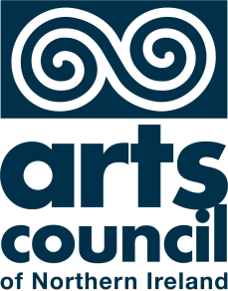

Regularly Funded
Organisations Survey
2013/14

Key data from the 2013/14 Regularly Funded Organisations survey

Strategic Development Department
December 2014
Contents

1. Introduction 5
1.1 Data verification 5
1.2 Organisations by artform 6
2. Staffing 7
3. Finance 9
3.1 Income 9
3.2 Income changes since 2012/13 10
3.3 Expenditure 11
3.4 Expenditure changes since 2012/13 12
4. Arts Activities 13
4.1 Headline results: total arts activities 13
4.2 Groups Targeted 13
5. Participation based activity 18
6. Performances 20
7. Exhibitions 22
8. Resource Organisations 24
9. Activity location 25
9.1 Overall activity 25
9.2 Deprivation 30
9.3 Neighbourhood Renewal Areas 31

Summary of findings
- In 2013/14, 109 organisations received £13.67m in funding (exchequer and lottery). The largest proportion of this (32 percent) was distributed to organisations working in Combined Arts.

- Regularly funded organisations employed 5,108 staff in 2013/14. In addition, a further 1,835 were recruited in voluntary capacities. Of the permanent staff employed, 422 worked full-time and 296 part-time.

- Excluding capital sources, total income equated to £48.1m. The largest single source generated from grant income (£26.0m) followed by earned income (£19.8m). Compared to 2012/13 Grant income fell by 10 percent and earned income increased by 9 percent.

- Total expenditure equated to £50.0m. Fifty six percent related to programme costs and 44 percent core costs. Compared to the previous financial year, expenditure increased by 6 percent.

- Regularly funded organisations delivered 29,305 events: 24,171 performances; 4,693 participation based events and 445 exhibitions.

- The largest proportion of activity delivered this year was targeted at children and young people (40 percent) followed by socially / economically deprived groups (22 percent).

- An ‘accessible venue’ was the method most frequently used to support access to events (69 percent), followed by ‘affordability’ (62 percent) and outreach (39 percent).

- Over 427,000 people participated in arts based activity in 2013/14. Visual arts were most frequently used to deliver this activity, used within 37 percent of activities.

- In 2013/14, 60 organisations delivered 24,516 performances. Total audiences of 1.82m were reported. Based on a constant sample of 44 organisations total audiences of 1.45m were achieved, an increase (compared to 2012/13) of 24 percent.

- In 2013/14, 51 organisations reported holding one or more exhibitions. Total ‘known’ audiences for this year were reported as 183,939. Seventy five percent of exhibition based activity was delivered in the most deprived 10 percent on Northern Ireland.

- Overall 50 percent of activity took place in the most deprived areas of Northern Ireland. By activity type, this ranged from 41 percent (participation) to 75 percent (exhibitions). Sixty one percent of all people engaged in the arts did so in these areas.

- Fifty three percent of activity was delivered within designated Neighborhood Renewal Areas.

Introduction
Each year arts organisations receiving regular, core funding from the Arts Council of Northern Ireland through the Annual Funding Programme (AFP) are asked to provide information on their organisation’s profile, finances and activity (performances, exhibitions and participation based activity). This report provides a high level summary of this activity generated through the Regularly Funded Organisation (RFO) survey.

This represents the last report based on the current survey mechanism. A new survey (the Annual Funding Survey) has been designed and rolled out by the Arts Council to reflect evolving client activity and changing information needs. Client activity delivered in 2014/15 will be collected using this new mechanism, with results available in September 2015.

The RFO survey is designed primarily as a monitoring tool, providing the Arts Council with evidence of activity and outputs. The Council uses the information collected for a variety of purposes: to report to government, to support the work of funded organisations and assess the effectiveness of the Annual Funding Programme.

The 2013/14 RFO survey was completed by 109 funded organisations. These organisations were awarded a total of £13.7m from both exchequer and lottery sources. A full list of organisations in receipt of funding can be found in Appendix 1. The report’s layout is largely consistent with the order of the survey sections. Following consideration of the artform characteristics, staffing and finance (two areas relevant to the whole sector) are analysed. The report then goes on to consider the main activity areas: participation, performances and exhibitions. Finally, the work of resource organisations is looked at.

Data verification

In a number of instances it has been necessary to exclude extreme responses to ensure trends displayed are an accurate reflection of the portfolio. Referred to as outliers, these figures have been removed as they tend to obscure trends.

So that data can be compared between the 2012/13 and 2013/14 surveys, a constant sample of organisations responding to both years has been compiled. The number of organisations comprising this sample varies between each area of activity.

Different methods used to record audiences and participants engaged in activity creates reliability issues when analyzing data. To reduce associated error, organisations are asked to report figures as either ‘actual’ or ‘estimated’, depending on the confidence they have in the data.

Organisations by artform

Regularly funded organisations are classified into one of seven different artform categories. The artform assigned to an organisation relates to the principal area of its work. The following classifications are used in this report:

- Combined arts
- Dance
- Literature
- Music
- Visual Arts
- Traditional Arts
- Drama

Table 3 shows the breakdown of the RFO portfolio by artform. There were 109 organisations included in the 2013/14 portfolio, with the most strongly represented artform being Combined Arts, comprising 33 percent of the portfolio with 30 organisations. These organisations receive a total of £4.4m in funding, constituting 32 percent of the total budget.

Drama and Music also receive a significant proportion of funding, drawing down 24 and 23 percent of the overall budget. In comparison, Dance has the lowest representation in the 2013/14 portfolio with 4 organisations. These organisations receive £286,667, 2 percent of the budget.

Table 1: Number of organisations by artform classification
Artform | Number of regularly funded organisations | Percentage of funding | Percentage of organisations
Combined Arts | 33 | 32 | 30
Dance | 4 | 2 | 4
Drama | 19 | 24 | 17
Literature | 8 | 4 | 7
Music | 11 | 23 | 10
Visual Arts | 20 | 4 | 18
Traditional Arts | 14 | 10 | 13
All artforms | 109 | 100% | 100%

Staffing

The full sample of regularly funded organisations (N=109) employed a total of 5,108 staff in 2013/14. 754 were permanent staff in either full-time or part-time capacity and 4,354 were contract staff in either artistic or managerial positions. In addition to this, 1,835 volunteers (both full-time and part-time) gave their time to support and enhance the work of funded organisations.

Based on a constant sample of organisations (N=94) between 2012/13 and 2013/14, there was a 2.8 percent decrease in permanent staff, a 4.0 percent increase in contract staff and a 1.3 percent increase in volunteers.

Figure 1: Comparison of staff numbers between 2012/13 and 2013/14, constant sample (N=94)

Of the permanent staff employed in 2013/14, a total of 442 worked full-time and 312 part-time. A comparison with the previous year (based on a constant sample of 94 organisations) indicates marginal reductions in the proportion of people employed in these capacities; 3.2 percent for full-time personnel and 2.3 percent for part-time personnel.
As can be seen in Figure 2, there was no change in the proportion of people employed on either a full-time and part-time basis between the two year, with the proportion of people employed on a full-time basis comprising 59 percent of staffing complements.

Figure 2: Breakdown of permanent staff in 2012/13 and 2013/14, constant sample (N=94)

Finance
Each organisation in receipt of AFP funding is required to submit details of income and expenditure relating to the financial year 1 April 2013 to 31 March 2014. All data in this section comes from each organisation’s actual or provisional accounts for that period. In order to ensure consistency, figures relating to grants awarded are taken from the Arts Council’s own records.

Income
Table 2 shows the breakdown in income by core category. Direct comparisons by artforms should be avoided due to variability in the number and size of organisations that comprise each artform. Total income for regularly funded organisation was £50.5m (including capital sources). Excluding Capital sources, total income equated to £48.1m. The largest single source of income was generated from grant income (£26.0m) followed by earned income (£19.8m).

Table 2: Breakdown of total income by category, 2013/14 (N=109) (‘000)
 | Grant Income | Earned Income | Contributed Income | Capital Income | Total Income
Drama | 5,251 | 9,208 | 446 | 96 | 15,001
Combined Arts | 11,021 | 7,163 | 946 | 237 | 19,367
Music | 3,341 | 1,346 | 559 | 1,256 | 6,502
Literature | 1,711 | 680 | 105 | 238 | 2,734
Visual Arts | 2,499 | 679 | 146 | 145 | 3,470
Traditional Arts | 1,782 | 635 | 41 | 124 | 2,582
Dance | 484 | 95 | 60 | 251 | 891
Total | 26,089 | 19,805 | 2,305 | 2,348 | 50,547

Figure 3 shows the breakdown of income by artform. With the exception of drama, grant income comprises the largest proportion total income for all artforms at 52 percent and ranges between 35 percent for Drama to 72 percent for Visual Arts.

Figure 3: Breakdown of total income by artform, 2013/14 (N=109)

Overall, earned sources comprised 39 percent of income, ranging between 61 percent for drama to 11 percent for dance. Combined contributed and capital income comprised 10 percent of overall income, with capital income contributing a significant source of income for Dance (28 percent).

Income changes since 2012/13

Table 3 shows the percentage change in income between 2012/13 and 2013/14. The comparison is based on a constant sample of 93 organisations.

Table 3: Percentage change in income sources, 2012/13 and 2013/14. (‘000)
 | 2012/13 | 2013/14 | % change
Grant | 25,716 | 23,177 | -9.9
Earned | 17,097 | 18,655 | 9.1
Contributed | 1,887 | 1,685 | -10.7
Overall | 45,987 | 46,872 | 1.9
Notes:
- Based on constant sample of 93 organisations
- Excludes capital income

Total income increased by 1.9 percent between 2012/13 and 2013/14. Grant income fell by nearly 10 percent (£2.5m) but was offset by a corresponding increase in the proportion of Earned income generated. This increased by 9 percent (£1.5m) between the two periods. There was also a reduction of 11 percent in contributed income, although the amount accrued was relatively small when compared to that generated from Grant and Earned sources.

Expenditure

Table 4 shows the breakdown in expenditure by the two main categories, core and programme. Organisations in the 2013/14 portfolio spent £50.0m, slightly less than combined income.

Core costs relate to day-to-day outgoings that keep the business functioning including administrative costs such as rent and rates, lighting and heating. Programming costs on the other hand, relate to costs incurred in delivering the artistic product or main programme of activity such as artists’ costs, volunteer expenses, publicity and marketing.

Table 4: Breakdown of expenditure by category, 2013/14 (N=109) (‘000)
 | Core costs | Programme Costs | Total
Combined Arts | 10,041 | 10,123 | 20,164
Dance | 290 | 604 | 894
Drama | 5,497 | 9,481 | 14,979
Literature | 1,448 | 1,303 | 2,751
Music | 1,515 | 3,843 | 5,358
Traditional Arts | 998 | 1,472 | 2,470
Visual Arts | 2,381 | 1,047 | 3,415
Total | 22,170 | 27,873 | 50,031

With the exception of Literature and Visual Arts, Programme expenditure exceeded Core costs. Total programme costs were £27.9m, compared to £22.2m Core costs.

Figure 4: Breakdown of total expenditure by artform, 2013/14 (N=109)

Figure 4 shows the breakdown of expenditure by artform. For the whole sector, core costs comprised 44 percent of expenditure with programme costs comprising 56 percent. Music and Dance had the largest Programme costs (72 percent and 68 percent respectively). Visual Arts organisations had the greatest proportion of Core costs (70 percent).

Expenditure changes since 2012/13

Table 5 shows the percentage change in expenditure between 2012/13 and 2013/14. The comparison is based on a constant sample of 93 organisations.

Table 5: Percentage changes in breakdown of expenditure, 2012, 13 and 2013,14. (‘000)
 | 2012/13 | 2013/14 | % change
Core costs | 19,245 | 20,159 | 5
Programme costs | 23,441 | 25,274 | 8
Overall | 42,686 | 45,433 | 6

Total expenditure increased by 6 percent between 2012/13 and 2013/14. Core costs increased by 5 percent (£914k), with programme costs increasing by 8 percent (£1.8m).

- Arts Activities
This section presents data on activities delivered by the 109 regularly funded organisations during 2013/14. For activities that present or engage individuals directly through artistic activity, the number of activities and audiences are broken down by artform classifications.

Headline results: total arts activities
Regularly funded organisations in 2013/14 delivered 29,305 performances, exhibitions and participation based events. This can be broken down into:

- 4,693 participation based events;
- 24,171 performances (3,863 productions); and
- 445 exhibitions

Groups Targeted

The Arts Council monitors the extent to which funded organisations target groups within society. This includes socially or economically marginalised groups, older people and those living in rural areas.

Within this context, targeting can take the form of a number of actions including publicity, inducements (such as discounted ticket prices) or outreach work delivered within a specific geographical location. Often this work is delivered in collaboration with local community and voluntary groups which provide area based knowledge and insight, adding value to the activity delivered by arts organisations.

Figure 5: Breakdown of activity targeted at groups, 2013/14 (N=7,815)

Figure 5 shows the proportion of activity targeted at recognised groups for all activity types. Excluding ‘no targeting’, Children or young people were targeted most frequently by funded organisations. Forty percent of activity was aimed at this group, reflecting the strategic priority placed on engaging this cohort in the arts. A significant proportion of activity was also targeted at socially or economically deprived groups (22 percent), disabled people (17 percent) and older people (16 percent).

These findings do not demonstrate success in reaching the specific group (a judgement more relevant to post-project evaluation phase). It is useful to note the group, or number of groups, the activity was intended to reach, as this has important implications for the form the activity takes, the methods used to support access and the marketing methods employed.

Figure 6 shows the proportion of activity targeted at groups by activity type. As a proportion of overall activity, the majority of both performance and exhibition activity was not targeted at any specific group (57 percent and 54 percent respectively). In comparison, 75 percent of participation based activity was targeted at one or more of the eight designated groups, reflecting a greater tendency for participation based mediums to be used within community contexts to address issue based topics.

Disabled people (7 percent) and older people (11 percent) were targeted on significantly fewer occasions via performance based activity compared to participation and exhibitions.

Figure 6: Breakdown of groups targeted by form type, 2013/14 (N=7,815)

Regularly funded organisations use a range of methods to promote access to the arts to overcome physical, attitudinal and procedural barriers that might otherwise inhibit the involvement of the whole community.
Figure 7 show the methods used to support access to performances, participation events and exhibitions by core clients. The four most frequently used methods to support access were: promoting accessibility (69 percent), affordability (62 percent), outreach (39 percent) and group targeting (36 percent).
There are a number of factors that influence the range and extent of methods used by organisations to support access. These include organisation remit / function and funder priorities. The cost associated with implementing the method used also plays a significant role, particularly where methods used are event / activity specific such as providing text in different format and support worker costs. The extent to which these methods have been used has fallen over the last three years as programming budgets have become more restricted.
Figure 7: Breakdown of methods used to support access, overall, 2013/14 (N=7,815)

Figure 8 shows little significant variation on methods used to support access by activity area. The only variability of note being the increased tendency for participation based activity to be associated with outreach (56 percent) and group targeting (46 percent) based activity. Significantly less outreach activity and group targeting work was combined with performance based activity, extensively due to the marketing work of larger performance based venues which was targeted at the general population level.

Figure 8: Breakdown of methods used to support access by activity area, 2013/14 (N=7,815)

Figure 9: Breakdown of venues used to deliver activity, 2013/14 (N=7,319)

Figure 9 shows the breakdown of the type of venues used. A large proportion of activity in 2013/14 took place in dedicated arts venues such as arts centres (27 percent) and theatres (22 percent).
There was little change in the proportion of activity taking place in these locations. However, the trend for activity to be delivered in venues and at locations not normally associated with arts activity continues this year with an increasingly larger proportion of activity being delivered in community organisations, youth clubs and outdoor locations. This reflects an increasingly mobile arts sector, able to engage communities within their own neighbourhoods.

Participation based activity
Regularly funded organisations deliver a range of participation based activity such as workshops, seminars, classes and outreach work and details of these form part of their annual returns.
In 2013/14, 97 organisations reported delivering participation based activities, 88 percent of the total portfolio for the year. These organisations delivered 4,693 activities and engaged with 427,006 individuals.
Comparison with 2012/13 based on a constant sample of 73 organisations shows an increase of 12 percent in the number of activities delivered. However, there was also a significant decrease in the number of participant (15 percent).
Table 6: Number of participants (full and constant sample), 2012/13 and 2013/14.
 | Full sample |  | Constant sample (n=73)
 | Number of activities | Number of participants | Number of activities | Number of participants
2012/13 | 3,714 | 423,138 | 3,690 | 418,795
2013/14 | 4,693 | 427,006 | 4,149 | 355,201
Note: includes both estimate and known participants
Table 7 shows a breakdown of the most popular artforms used to deliver participation based activities. Visual arts was used in 37 percent of activity (n=1,538), followed by Combined arts (18 percent) and Drama (13 percent). Of note was the variety of artforms used by organisations to deliver activity, with a significant number using film, culturally specific dance and classical music.
Table 7: Breakdown of artforms used in participation based activity, 2013/14
Artform | Number of activities | Percentage
Visual Arts | 1,538 | 37%
Combined arts | 736 | 18%
Drama | 546 | 13%
Crafts | 488 | 12%
Other music | 466 | 11%
Culturally specific music | 347 | 8%
Children’s youth theatre | 251 | 6%
Theatre entertainment | 235 | 6%
Literary events | 232 | 6%
Other (n=15) | 1,485 | 37%

Figure 10 shows the broad religious affiliation of participants engaged in participation based activity. Regularly funded organisations are asked to provide information on the overall religious composition of those taking part in participation based activities. In most cases, the classification of participants into the designated categories is determined based on the knowledge of activity facilitators. The results should therefore only be regarded as approximate.

Figure 10: Religious profile of participants, 2013/14 (N=2,120)

Sixty eight percent of activity was described as cross-community, involving a mix of individuals from both the main community backgrounds. It is likely that a significant proportion of activity involving participants from one background was delivered in single identity communities as part of outreach work.
Figure 11 shows the percentage breakdown by age group of participants engaging in activity during 2013/14. The largest proportion of participants are aged 11 years or younger (26 percent) followed by those aged between 40 and 59 (18 percent).
Figure 11: Percentage breakdown by age group in participation based activity, 2013/14 (N=3417)

Performances
Regularly funded organisations collect attendance figures and ticket information as part of their funding agreement with the Arts Council. This information is collected at a production and performance level building a comprehensive portfolio of evidence year on year. This data, some of which is sourced from electronic box-office systems, is used by funded organisations to build detailed customer profiles enabling them to develop engagement strategies.

In 2013/14, 60 organisations (55 percent of sample) delivered 24,516 performances. Total audiences of 1.82m were reported. Based on a constant sample of 44 organisations total audiences of 1.45m were achieved, an increase (compared to 2012/13) of 24 percent.

Figure 12: Comparison of audiences, 2012/13 and 2013/14
 | Full sample |  | Constant sample (n=44)
 | Number of performances | Total audiences | Number of performances | Total audiences
2012/13 | 18,240 | 1,278,947 | 14,863 | 1,176,929
2013/14 | 24,516 | 1,824,826 | 19,327 | 1,454,471
Note:
Audience figures includes known and estimated attendance

Table 8 shows the breakdown of audiences by artform. Combined Arts and Drama shared over three-quarters of the audience in 2013/14.

Table 8: Total audiences by artform, 2013/14 (N=24,516)
Artform | Total Audiences as percentage of total
Combined Arts | 47
Drama | 35
Dance | 8
Music | 6
Traditional Arts | 3
Literature | 1
Note:
Audience figures include known and estimated audiences

Figure 13 shows the breakdown of ticket sales by type (full-price, discounted and concessionary). Based on the overall sample, 84 percent of tickets distributed were sold at full-price. At an artform level, Dance distributed the largest proportion of tickets at full-price (97 percent), followed by Drama (87 percent) and Combined Arts (83 percent).

Figure 13: Breakdown of percentage ticket sales by type, 2013/14 (N=24,171)
 | Full-price | Discounted | Concessionary
Drama | 87 | 9 | 4
Combined Arts | 83 | 12 | 5
Music | 70 | 19 | 11
Traditional Arts | 73 | 26 | 2
Dance | 97 | 3 | 0
Total | 84 | 11 | 5

Exhibitions

As with other years, audience figures submitted by some organisations presenting exhibitions showed a degree of volatility compared to other activity areas, with a general lack of consistency shown between years, particularly at an organisation level. This is largely due to the nature of events, some of which are in public spaces and displayed over prolonged periods and the methods of data collection which are often limited to head-counts or broad estimations.

As with other activity areas, organisations holding exhibitions were asked to report audience figures as either ‘known’ or ‘estimated’. A higher degree of confidence can be placed in known figures as these are recorded using dedicated monitoring techniques.

Table 9: Comparison of known exhibition audiences, 2012/13 and 2013/14
 | Number of exhibitions (for known audiences) | Known audiences | Average audiences based on known audiences
2012/13 | 165 | 179,240 | 1,086
2013/14 | 188 | 183,939 | 978

Table 9 shows a comparison of known audiences between 2012/13 and 2013/14. In 2013/14, nearly 184,000 people were known to have attended 188 exhibitions. This represented an average audience of 978 per exhibition, slightly lower than the equivalent for the previous year.

The inclusion of estimated attendance for 2013/14, inflates engagement to 643,265. These attenders visited 445 exhibitions. This represents a reduction of 150,047 visits compared to the previous year, although the degree of confidence that can be placed in these figures is more limited. Ninety nine percent of exhibitions presented in 2013/14 were free of charge at the point of entry.

Seventy percent of exhibitions in 2013/14 were produced by single organisations. Twenty seven percent were produced in partnership with other organisations, with the remaining 2 percent comprising exhibitions toured from outside Northern Ireland.

Figure 14 shows a breakdown of exhibition audiences by artform area. Combined Arts and Visual Arts shared the highest audiences, comprising 90 percent of total audiences.

Figure 14: Breakdown of attendance at exhibitions (known and estimated), 2012/13 (N=445)

Others relate to: music, drama, traditional arts and dance

Resource Organisations
In 2013/14, the Arts Council supported 10 organisations to provide dedicated advice and support services to arts organisation and individual artists.

These organisations offer a dynamic mix of sector development and career enhancement supports tailored for the sector they work in. These supports can be reduced down to a core set of activities, the quantum of which is shown in Table 10.

Table 10: Summary of supports provided by Resource Organisations, 2012/13
Activity | Total
Bursaries | 18
Newsletter distributed (electronic and hard-copy) | 101,453
Enquiries dealt with | 14,673
Number of artists supported | 2,203
Provided advocacy support | 781
Artists provided with premises | 679
Talks or lectures organised / delivered | 123
Training courses organised / delivered | 102
Residencies arranged | 30

These organisations offer a mix of services refined to meet particular needs, their role often evolving over a period of time to reflect the context in which they work – reflecting both artistic needs and often the needs of the local community they operate in. Resulting supports are often specialised but include advice, advocacy support, professional representation and training opportunites.

Communication with members via newsletters remains a significant and growing dimension of their work. Over 100,000 newsletters were distributed in 2013/14, highlighting their recognised value in enhancing communication networks. Thirty residencies were arranged for practising artists, allowing artists time and space away from their day-to-day routine to develop their practice.

Activity location
By analysing the postcode data submitted by regularly funded organisations relating to the location of performances, participation and exhibitions, the Council is able to map its spatial distribution against a range of variables which include deprivation, regeneration and urban/rural classifications. This allows us to demonstrate the value of our core funded clients’ work in relation to government priorities in the same areas.

In order to map the location of activity, valid postcodes are required. Table 11 shows the proportion of activity locations that were associated with valid postcodes. 86 percent of activity was mappable.

Table 11: Proportion of ‘mappable’ postcodes by activity type, 2013/14.
 | Number of activities | Number of valid postcodes | Percentage of valid postcodes
Exhibitions | 445 | 194 | 43%
Participation based activity | 4,676 | 4,093 | 88%
Productions / performances | 3,863 | 3,418 | 88%
Overall | 8,984 | 7,705 | 86%

Overall activity

As can be seen in Table 12, the majority of activity, regardless of type, took place in Belfast and Derry~Londonderry. Fifty eight percent took place in Belfast with 20 percent in Derry~Londonderry.

Table 12: Location of activity by Local Authority Area
 | Number of activities | Sum of people engaged | Percentage of engagement
BELFAST | 4,266 | 1,239,061 | 58%
DERRY | 1,230 | 432,660 | 20%
All Other Local Authorities (n=24) | 2,209 | 456,461 | 21%
Total | 7,705 | 2,128,182 | 100%

Figures 17 to 20 show the distribution of activity overall and broken down by type during 2013/14 by Local Authority area. Participation based activity was delivered at the largest number of unique venues, reflecting its more mobile nature. Conversely, exhibition based activity tended to be more static; dependent on resources within fixed venues.

Figure 15: Distribution of all Regularly Funded Organisation activity (N=7,705)
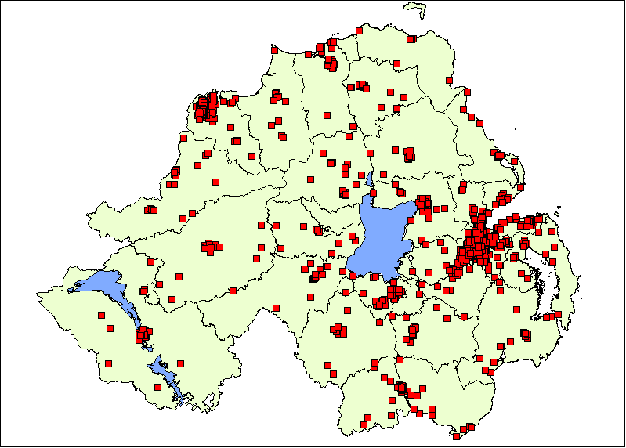
Figure 16: Distribution of participation based activity (N=4,093)
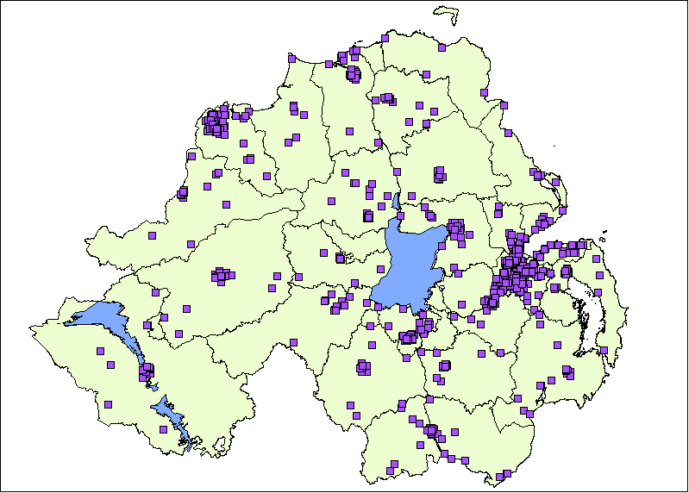
Figure 17: Distribution of exhibition activity (N=194)
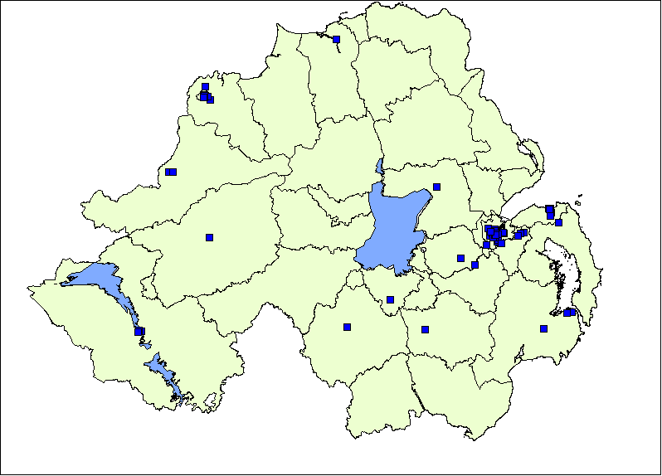
Figure 18: Distribution of production (performance) based activity (N=3,418)
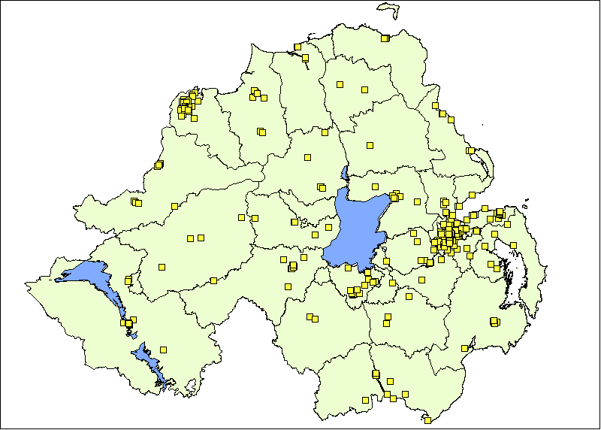

Deprivation

The Multiple Deprivation Measure (MDM) is the official measure of area based multiple deprivation used in Northern Ireland. The 2010 index (used here) is comprised of 52 indicators mostly relating to data collected between 2007-2009. The indicators are grouped into seven types or ‘domains’ of deprivation which are then weighted.

Figure 15 shows the distribution of activity by Multiple Deprivation. The extent or severity of deprivation is divided into ten equal parts (or decile), ranging from the most deprived to the least deprived. The extent of activity taking place in each of these areas is shown in percentages.

Figure 19: Distribution of activity of Multiple Deprivation Measure, 2013 (N=7,705)

Overall, 50 percent of all activity took place in the most deprived areas of Northern Ireland. By activity type, this ranged from 41 percent (participation) to 75 percent (exhibitions).

The static nature of performance and exhibition venues, a significant proportion of which are located within deprived, urban areas, means activity tends to be skewed towards these areas. Participation based activity, by its very nature is more mobile and delivered in locations such as hospitals, community centres and village halls.

Table 13 shows the distribution of engagement by deprivation in percentage terms. Overall, 61 percent of engagement took place within the most deprived decile or 10 percent of Wards.

Table 13: Distribution of audiences by Multiple Deprivation Measure
Decile of Multiple Deprivation Measure | Number of activities | Percentage of activity | Percentage of engagement
Most Deprived: 1 | 3,999 | 50% | 61%
2 | 388 | 5% | 6%
3 | 434 | 5% | 5%
4 | 442 | 6% | 6%
5 | 196 | 2% | 2%
6 | 868 | 11% | 4%
7 | 251 | 3% | 2%
8 | 319 | 4% | 1%
9 | 298 | 4% | 4%
Least Deprived: 10 | 798 | 10% | 7%
Total | 7,993 | 100% | 100%

Neighbourhood Renewal Areas

Under Government’s People and Places Strategy, 36 of the most deprived neighbourhoods across Northern Ireland have been designated as Neighbourhood Renewal Areas (NRAs). The strategy is cross-government, bringing together the work of all departments, in partnership with the community and voluntary sector, to tackle deprivation.

Figure 20: Proportion of activity delivered in Neighbourhood Renewal Areas, 2013/14

Figure 16 shows the proportion of activity delivered by the portfolio of regularly funded organisations that fell within designated NRA’s. In 2013/14, this equated to fifty three percent (n=4,301) of activity, involving a total of 1.67m people either as audiences or participants.

Appendix 1 – Organisations in receipt of Annual Funding Programme funding in 2013/14
ADAPT NI | Community Arts Partnership | McCracken Cultural Society
Aisling Ghear Theatre Company | Craft and Design Collective | Moving on Music Ltd
All Set Cross Cultural Project | Craft Northern Ireland | Music Theatre for Youth
An Droichead | Creative Exchange | New Lodge Arts
An Gaelaras Ltd | Crescent Arts Centre | NI Opera
Andersonstown Trad Music School | Culturlann McAdam O'Fiaich | Northern Ireland Piping & Drumming School
Armagh Rhymers Educational & Cultural Organisation | Dance Resource Base (NI) Ltd | Northern Visions Ltd.
Array Studios | DU Dance | Oh Yeah Music Centre
Arts and Disability Forum | Derry Theatre Trust | Open Arts
Arts Care | Digital Arts Studios | Open House Festival
Arts for All | Down Community Arts Ltd | Orchid Studios Association
Belfast Community Circus School | Drake Music Project Northern Ireland | Panarts
Belfast Exposed Photography | Dun Uladh Ltd | Paragon Studios
Belfast Festival at Queen's | Echo Echo Dance Theatre Company | Partisan Productions
Belfast Music Society | Enniskillen International Beckett Festival | PLACE
Belfast Print Workshop | Feile an Phobail | Play Resource Warehouse
Belfast Traditional Music and Dance Society | Flaxart Studios | POBAL
Big Telly Theatre Company | Glasgowbury | Poetry Ireland
Blackstaff Press Limited | Golden Thread Gallery | Millenium Court Arts Centre (Portadown 2000)
Bruiser Theatre Company | Greater Shantallow Community Arts | Prime Cut Productions Ltd
Cahoots NI Ltd | Green Shoot Productions | Prison Arts Foundation
Camerata Ireland | Guildhall Press | Queen Street Studios
Catalyst Arts Ltd | In Your Space (NI) Ltd | Replay Theatre Company
Centre for Contemporary Art | Irish Pages Ltd. | Seacourt Print Workshop Limited
Kids in Control | Irish Traditional Music Archive | Sole Purpose Productions
Spanner in the Works | Kabosh Theatre Ltd | Source Magazine
Comhaltas Ceoltoiri Eireann | Maiden Voyage (NI) Ltd | Sticky Fingers Early Years Arts
Streetwise Community Circus Workshops
Terra Nova Productions
The Beat Initiative
The Black Box Trust
The Cathedral Quarter Arts Festival
The Contemporary Music Centre Ltd
The Grand Opera House Trust
The John Hewitt Society
The Lyric Theatre (NI)
The MAC
The Nerve Centre
The Playhouse, Derry
The Royal Scottish Pipe Band Association
The Void Art Centre
Tinderbox Theatre Company
Tyrone Guthrie Centre at Annaghmakerrig
Ulster Association of Youth Drama
Ulster Orchestra Society Ltd
Ulster Youth Choir
Ulster Youth Orchestra
Ulster-Scots Community Network
Verbal Arts Centre
Voluntary Arts Network
Walled City Music Trust
Waterside Theatre Company Ltd
Wheelworks
Young at Art
Youth Action Northern Ireland

Includes contract and permanent employment, full-time and part-time
Calculation based on a constant sample of 93 organisations
Relates to sponsorship, income from trusts and donations
As compared against the Central Postcode Directorate released by NISRA, 2014
Domains and weightings include: Income (25%), Employment (25%), Health (15%), Education (15%), and Proximity to Services (10%), Living Environment (5%) and Crime (5%).
Includes both known and estimated audiences for performances, exhibitions and participation based activities

